US Disaster Recovery Test Report, March 2019

Serraview - US Production

Last revised by Nathan Damilatis, 27/3/2019

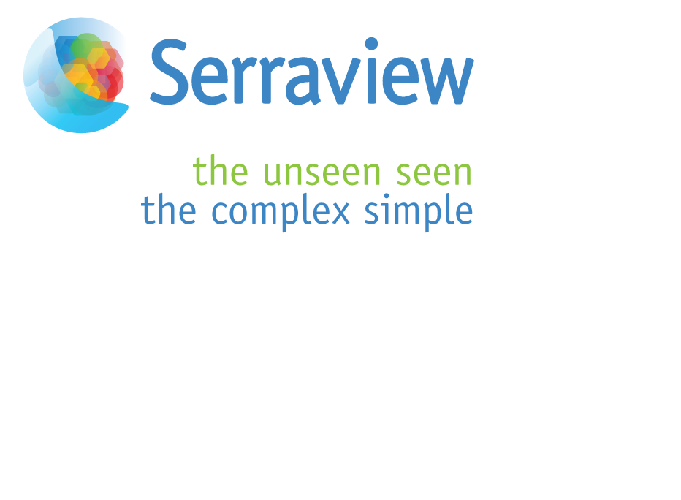

Table of Contents

Audience and Purpose 3

System Overview - US Production 4

Continuity Objectives 4

Systems Network Diagram 5

Test Overview 6

September 2017 Test Results 6

Remedial Actions 7

Document control 7

Version history 7

# Audience and Purpose

This document is created as part of the Business Continuity Process, and is intended for Serraview clients and internal staff. It describes the Serraview production Disaster Recovery (DR) provisions and the results of annual testing of the DR site.

# 

# 

# System Overview - US Production

The Serraview (Wayfinder) software provides the client’s Property Management Group with tools to facilitate the efficient use of real estate assets. This includes floor and building planning, seat allocation, usage reporting, hot-desking management and relocation planning.

Serraview’s US clients are serviced exclusively by hosting facilities in the US, located in Virginia and Texas.

The software is hosted by Serraview on dedicated hardware, which is managed by Rackspace and hosted in their data centres. This is operated by Serraview on behalf of clients using a Software-as-a-Service model for the Serraview application.

# Continuity Objectives

Serraview’s continuity objectives are stated in terms of the amount of time it would take to resume normal operations in case of a major event. Note that minor events will have a much faster recovery time.

A major event is one which renders all of the systems at one site unusable - for example a fire at the production data centre.

For a major event involving client-facing systems, our DR Recovery Time Objective (RTO) is 8 hours, while our Recovery Point Objective (RPO) is 24 hours.

Note that client systems are also designed with local resilience, so that no single component failure will cause a substantial outage or loss of data. The only exception to this is dual-sided failure of a Storage Area Network (SAN), which is unlikely and is considered a possible DR event.

# Systems Network Diagram

# 

# Test Overview

The Production servers are replicated to the DR site twice daily across a private link. The purpose of the testing is to:

1. Test the DR public-facing network connectivity
2. Validate that the replicated copies are not corrupted
3. Validate that the operating systems are functioning correctly
4. Validate that the database backups can be restored
5. Validate that the application functions
6. Ensure that the recovery time objective is met

# March 2019 Test Results

Disaster Recovery Tests were conducted on March 25th, 2019.

Time taken from start of test until application testing complete – 5 hours.

|  |  |
| --- | --- |
| **Test** | **Result** |
| Secured Admin VPN access to the DR Data Centre | Passed |
| Connection to DR firewalls | Passed |
| Accessing administrative interfaces on the DR servers | Passed |
| Activating the DR SQL Server(s) | Passed |
| DB Restore from replicated copy | Failed |
| Activating the Serraview application | Passed |
| Accessing the Serraview application | Passed |
| New Instance Checklist Tests - QA | Passed |
| Application queries to validate that data is from previous night's backup | Passed |
| Time to activate within RTO time limit | Passed |
| Data recovery within the RPO targets | Passed |

# Remedial Actions

Replication of SQL backups to the DR environment has been failing since October 2018. This was identified as part of the DR Test and as a result, the test could not be completed without retrieving a database backup from the Production environment. Once this backup was retrieved, the remainder of the testing proceeded without incident.

A project is already underway to change the backup process to utilize Amazon Web Services’ S3 for backup storage. This change will fully remediate the issue and ensure backups are always available in a disaster scenario.

# 

# Document control

## Version history

|  |  |  |  |
| --- | --- | --- | --- |
| **Version** | **Date** | **Author/s** | **Summary of changes made** |
| 0.1 | May 2019 | Nathan Damilatis | Initial Version |